Hello Everyone

2025 is a HOT Summer!

Some of you would have seen my garden if you came to the Base Open Studios. Here it is in Summer. This picture is artfully taken from a distance, so the weeds are not apparent! I do feel very lucky to have a garden, and I really enjoy it on sunny mornings, with a cup of coffee. It’s not so bad on rainy mornings, either. It’s a moment of calm, before the day ahead.

It’s not long until the next block printing workshop (Q3, 5th August 25). I have some new printing blocks and also some new stencils for you to try. They include these lovely mushroom blocks, which I think would look great printed with ferns and seed heads.

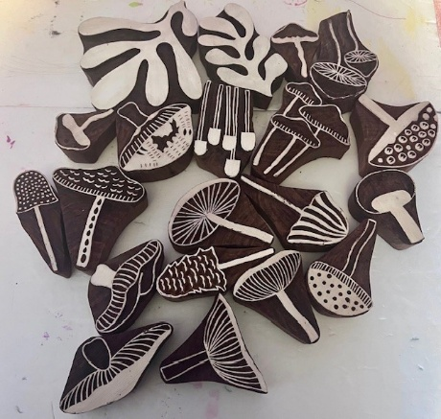

Included in the new printing blocks is a pomegranate block. I had a go at printing some linen napkins with this one and plan a matching table runner (when I have time left over from pulling the weeds out of my garden). Just a reminder that everyone is welcome to bring items of their own to print, if you want to print something special. I can even source items for you, if you give me a heads up.

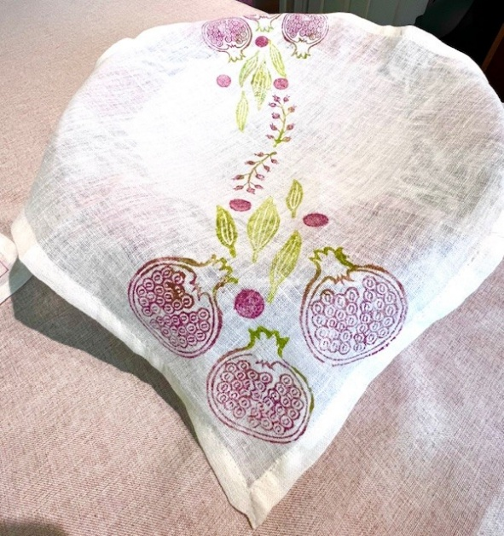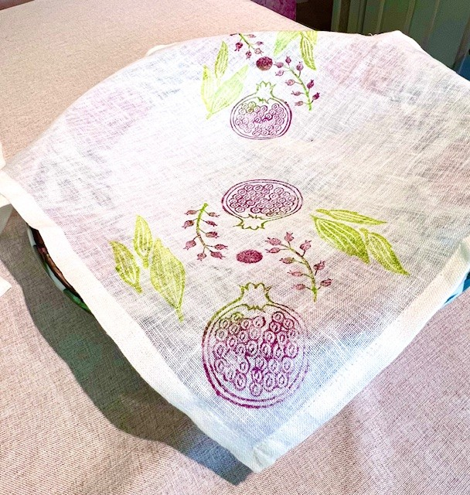

The Q3 workshop is sold out, but in case you missed it or couldn’t come, there is an opportunity to attend a workshop in October at the Link, Tadley.

The space at The Link is lovely, with lots of natural light. It’s being organised Tadley and District Community Association and I believe there are still places left. This is well timed to get Christmas cards and presents printed. Here are all the details

Since the last Newsletter, the Open Studio Exhibition at the Base took place. Here are my two pieces of artwork, “Protea” and “Scandi Scarf” (both fabric paint on silk). One, a stencil composition and the other a block print, to represent the printing we do at the workshops. Both pieces sold. It was a great experience and I’m looking forward to next year.

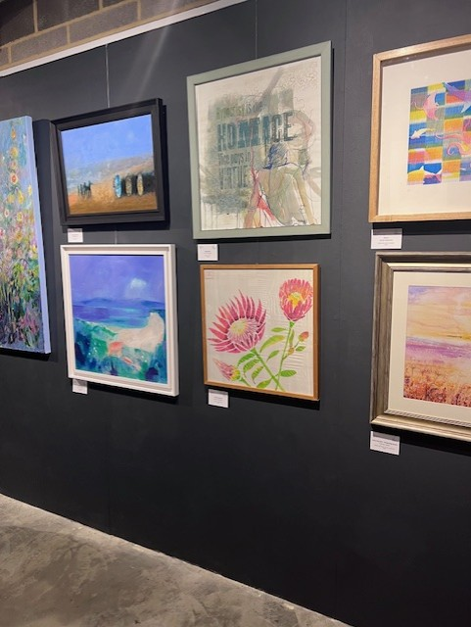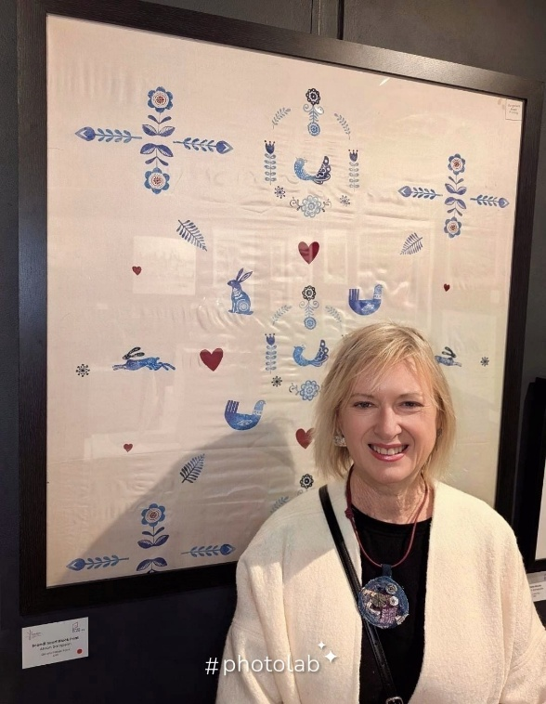

**Coming up**

Workshops and Bitesize

I have had some reasonable feedback for a longer workshop, and indeed, someone is printing for 4 hours at the Q3 workshop. I plan to offer this as an option at the next workshop.

Bitesize is always available.

Silchester Market

Our next outing will be Christmas, which seems so far away, but will be here with us before we know. You will be able to buy block printing kits as presents. If anyone wants something specific, please let me know. I recently asked to prepare a deluxe block printing kit which had blocks, stencils, multiple paints and several printing items. It was great fun sourcing everything for it.

Swallowfield Show

Come and find us in the “Activity Zone”.

Just a reminder that this year, **all workshop profits** go to the upkeep of St Mary’s Church, Burghfield Village.

That’s it for this Summer Newsletter. Well done if you’ve made it this far!

Alison (Lexii and Paul) x